EDA VISUAL OUTPUT:
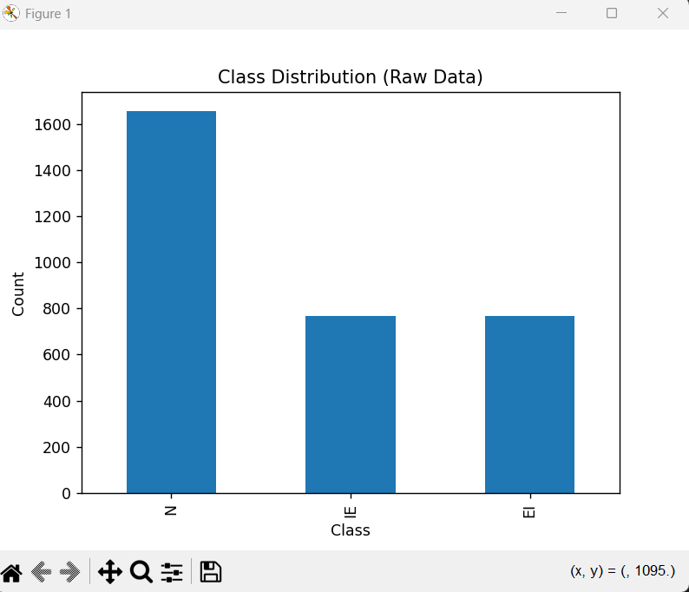
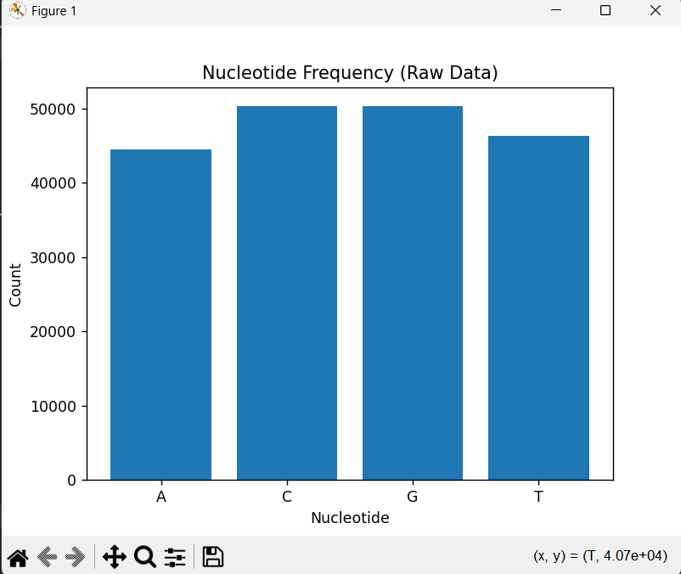

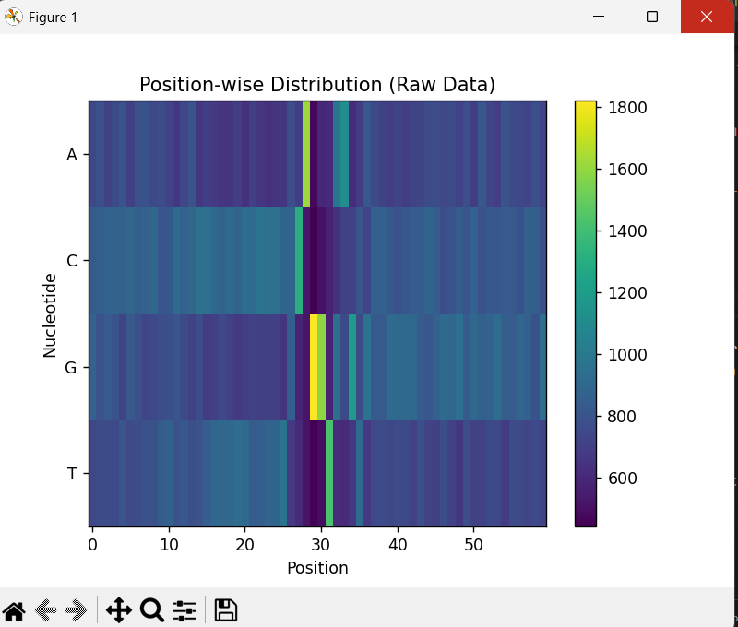
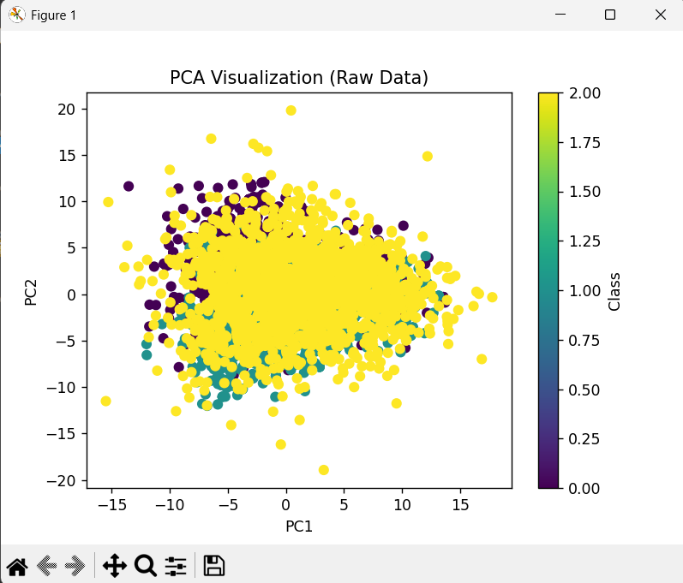
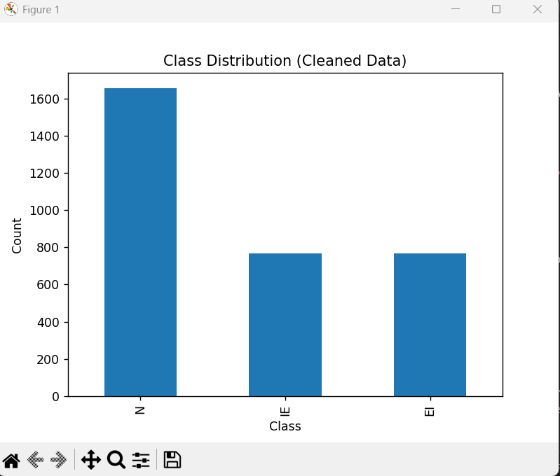
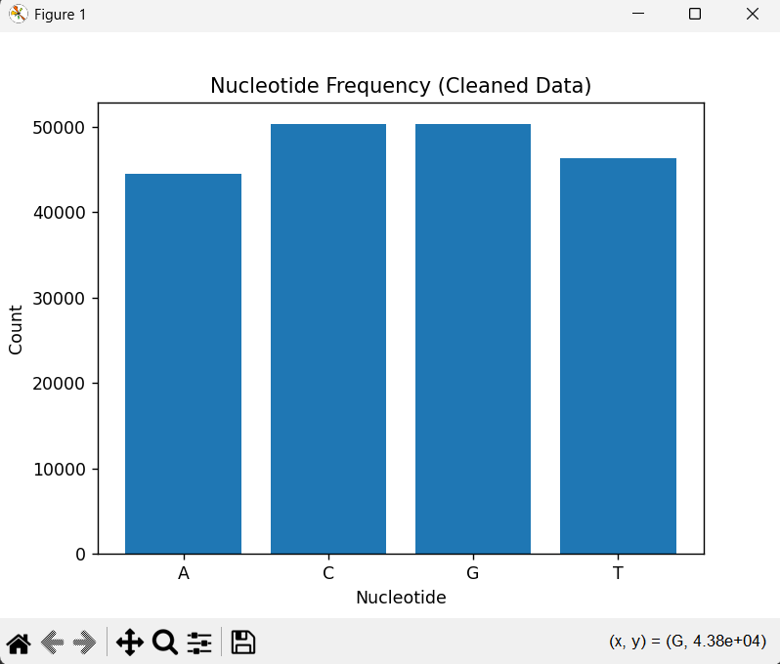
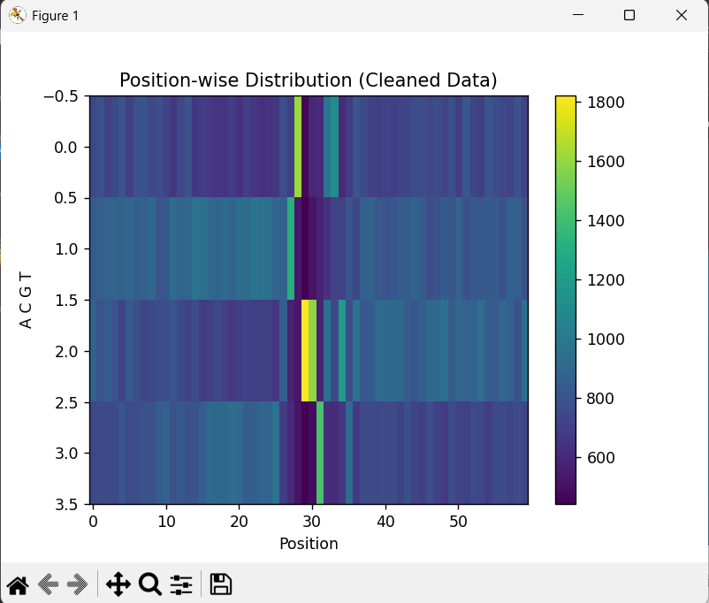
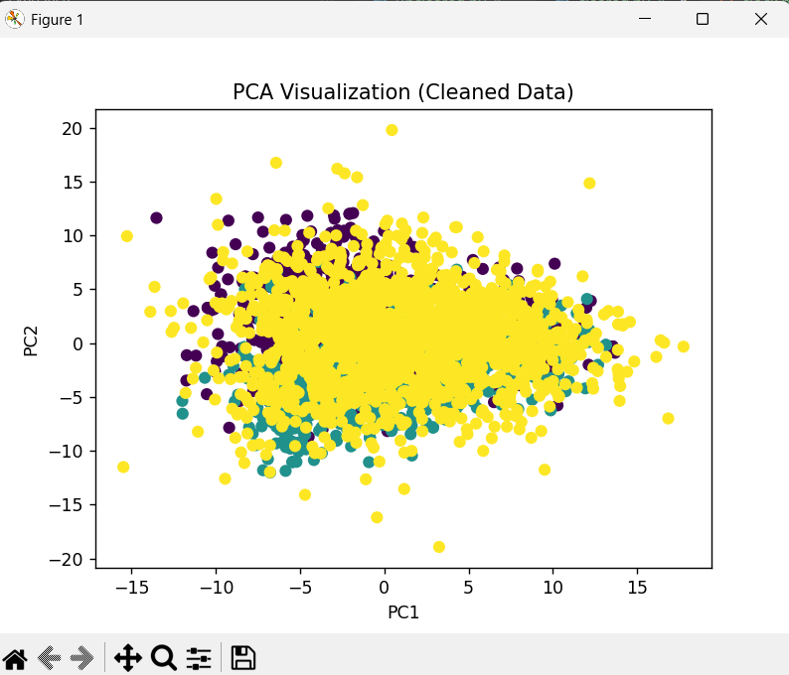

10. CONCLUSION
This project shows us how to find splice junctions using both KBANN and deep learning methods. It seems that the CNN model is the best when it comes to accuracy because it can learn patterns from the data.
At the time the KBANN model is really good at helping us understand the results thanks to its use of established biological rules. In summary the project shows that combining what we know about biology with machine learning techniques can give us results.
While the CNN model makes the predictions more accurate the KBANN model helps us understand the predictions which makes our approach more well-rounded.

11. FUTURE SCOPE
• We can use LSTM or Transformer models
• We can use genomic datasets
• We can use the system for real-time biological applications
• We can put the system on the cloud

12. REFERENCES
GITHUB LINK https://github.com/Prince-Devlpr/splice-junction-ml_
1. Dataset Source
- UCI Machine Learning Repository – Splice Junction Dataset
Organization: UCI Machine Learning Repository
Link: https://archive.ics.uci.edu/ml/datasets/splice
2. KBANN (Core Concept)
- Towell, G. G., & Shavlik, J. W. (1994).
Knowledge-Based Artificial Neural Networks
Journal: Artificial Intelligence
- Summary: Introduces KBANN, integrating domain knowledge into neural networks.
- Link: https://www.cs.wisc.edu/~shavlik/abstracts/towell.aij94.abstract.html
3. Machine Learning Book
- Tom M. Mitchell (1997)
Machine Learning
McGraw-Hill
- Widely used textbook explaining classification and neural networks.
4. Deep Learning Reference
- Ian Goodfellow, Yoshua Bengio, Aaron Courville (2016)
Deep Learning
MIT Press
- Link: https://www.deeplearningbook.org
5. CNN Concept (Research Paper)
- LeCun, Y., et al. (1998)
Gradient-Based Learning Applied to Document Recognition
- Introduces CNN architecture.
- Link: http://yann.lecun.com/exdb/publis/pdf/lecun-98.pdf
6. Bioinformatics / DNA Analysis
- Mount, D. W. (2004)
Bioinformatics: Sequence and Genome Analysis
- Covers DNA sequence analysis and biological concepts.
7. Python Libraries
(a) Pandas
- Organization: Pandas Development Team
- Link: https://pandas.pydata.org/docs
(b) NumPy
- Organization: NumPy Developers
- Link: https://numpy.org/doc
(c) Scikit-learn
- Organization: scikit-learn
- Link: https://scikit-learn.org/stable
(d) TensorFlow
- Organization: Google
- Link: https://www.tensorflow.org
8. Flask (Backend Framework)
- Organization: Pallets Projects
- Link: https://flask.palletsprojects.com
9. React (Frontend Framework)
- Company: Meta
- Link: https://react.dev
10. Research Papers on Splice Detection
- Burset, M., & Guigó, R. (1996)
Evaluation of Gene Structure Prediction Programs

